

What’s the buzz in November?



We’re glad to be back at school after our Halloween holidays! The children are settling in well after their break. We are coming into the colder weather so we would ask parents to make sure your child wears a warm coat to school as we are in the Outdoor Classroom every day. We are looking forward to the busy run up to Christmas and all the exciting events we have.



**Monthly Theme at Home**

The theme for this month is Traditional Tales and Fairy Tales.

Our colour is **yellow** and our shape of the month is a square.

We will be exploring this through books, stories and rhymes and artwork and you will see our outdoor area transformed into the three pigs building site.

Here are some simple ideas to try out at home together:

* Read traditional tales and fairy tales to your child at home – talk about your memories as a child of these stories.
* Plant beans with your child at home and see if a magic beanstalk will appear!
* Work together on the family project!
* Bake gingerbread men.
* Talk to your child about keeping safe, not going with strangers or going into people’s homes that they don’t know – make links to the characters in the traditional stories you have read.

The

The

**Family Project**

Thank you all for the hard work, you put in to making the pumpkins. They were amazing and you’ve all set the bar high for the rest of the projects!

This month, as we are learning all about Traditional Tales, the family project will be to create your own unique gingerbread man. Some ideas could be as simple as material for clothing and yarn for hair or your child could disguise their gingerbread into something else, e.g. Batman, or a princess. Please send the completed project back to school by Friday 24th November.





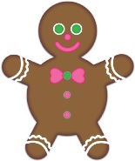

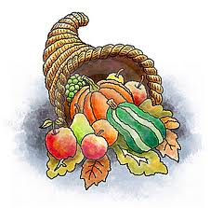



**Christmas Dates**

As we approach December, we are hoping to have lots of exciting events for the children to get them into the festive spirit. We will be hosting a Supper with Santa for the children on the evening of Wednesday 13th December. More details will follow.

The children will also perform their Nativity in the chapel this year so parents can come to watch. *Our First Nativity* will be performed on Tuesday 12th December. More details regarding exact times will follow.



**Parent/Teacher Meetings**

We are holding our Parent/Teacher meetings from Monday 13th November and Wednesday 15th November. Please make a note of the day and time you have chosen. This will be a 10-minute meeting to discuss your child’s progress in Nursery so far and will take place in your child’s classroom

[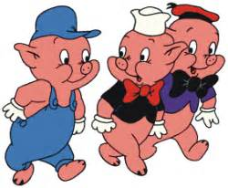](http://www.bing.com/images/search?q=three+little+pigs&view=detailv2&&id=E0A705FCC383EF331E18E1457A6426E4D459C92C&selectedIndex=17&ccid=mb+/jQxU&simid=607993960564985550&thid=OIP.M99bfbf8d0c547d16dce1786f223b9459H0)



**Nursery Birthdays**

Happy birthday to all these children who have birthdays during the month of November.

***12th- Mason Mellon***

***16th- Cian Edgar***

***20th – Billie Curran***

**Open Day**

Our Open Day for Nursery and P1 will take place on Friday 8th December. Parents can take children straight to the hall when they are collected from Nursery. This is a great opportunity to see what our school has to offer and to ask any questions you may have.



**Important Dates**

***10th November:*** *Non Uniform Day*

***13th & 15th November:*** Parent Teacher Meetings

**6th December:** Sperrin Fun Farm

**8th December:** Open Day

**12th December:** Nativity in St Mary’s Chapel

**13th December:** Supper with Santa

**Our Christmas Trip**

On Wednesday 6th December, we will be going to Sperrin Fun Farm to their Winter Wonderland Experience.

Children will be asked to bring a packed lunch to this trip. A lunch will be provided for any child on free school meals.

The cost of this trip will be reduced to £12 as the cost of the bus will be paid for from our snack fund.

**Reverse Advent Calendar**

This year in our Nursery we are going to have a “Reverse Advent Calendar”. It’s a way of helping people who are less well-off in our community. It involves putting one item of food aside each day over the month of December and the boxes will be delivered to the Foyle Food Bank in time for Christmas. If every child brought in one or two items a week, we should have plenty to donate. All food and toiletry items are very welcome. More details regarding dates will be given shortly. Thank you.