Holy Child

Primary and Nursery School
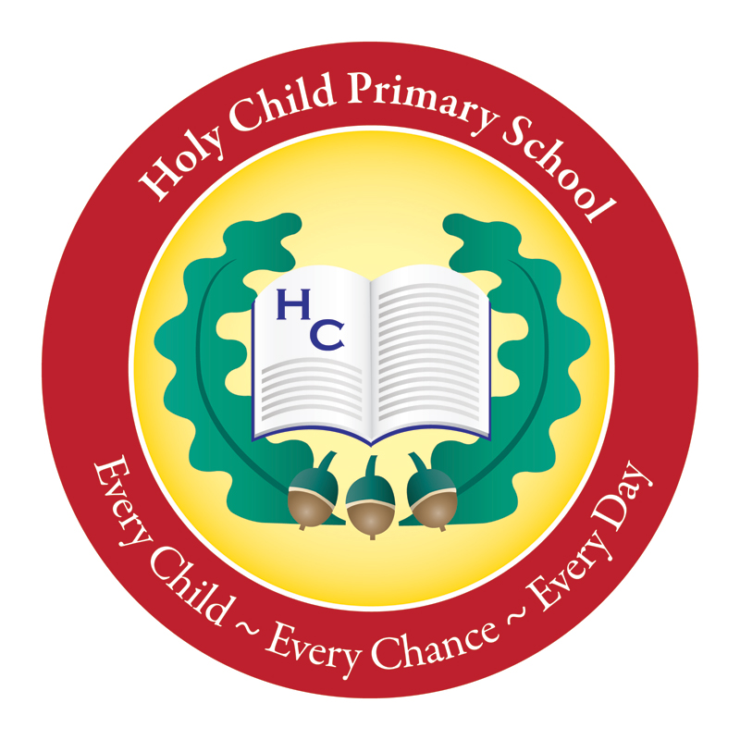

PICK UP POLICY

PRINCIPAL: Mrs N Cullen

Pick Up Policy / Safeguarding Children

In the interests of the children’s safety, it is important that everyone in school is clear about pick-up/collection routines and therefore we ask for your support in following the guidelines:
- It is important your child fully understands who is collecting them from school;

- Your child’s class teacher should be informed of any change to the normal daily pick-up arrangement;

- If you are unavoidably delayed please phone the office and let us know a.s.a.p. and we will take an appropriate course of action;

- Please advise your child that, if you do not arrive, he/she should report to the school office and wait for you there. This will reinforce what we are telling them in school and will avoid unnecessary worry;

In the interests of the children’s safety, to avoid the potential of accidents please ensure that you do not park on the yellow lines at the front of the school. This will also ensure traffic keeps moving along Central Drive plus access is still available for emergency vehicles.

It is school policy that children in P1-P3 classes should be collected by an adult unless otherwise agreed through discussion with the Principal.

Monitoring and Evaluating the Policy
This policy will be reviewed every three years or as required due to changes in guidelines/legislation or practice within school.

